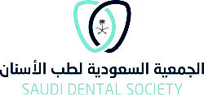

AGREEMENT
Applicants are strongly advised to read through the following guidelines and provisions for this section prior to writing the proposal.
- The principal applicant must be an active member of the Saudi Dental Society.
- The research project should be submitted as a proposal to the Saudi Dental Society.
- Applications will be evaluated based on merit, innovation, and relevance to the current research mission of the Saudi Dental Society.
- In cases where modifications in the Questionnaire are necessary, such modifications must be pre-approved again by the Saudi Dental Society.
- In all scientific and scholarly publications, oral & poster presentations in conferences, from this research project, authors must acknowledge the Saudi Dental Society.
For example: "We acknowledge that this research project was supported by the Saudi Dental Society, King Saud University”.

PRINCIPAL INVESTIGATOR
I confirm my/our agreement to the terms and policies mentioned above

(Name, signature & date signed)

